August 2023

**EVALUATING THE BEST SOFTWARE DEVELOPMENT TOOLS: A COMPARATIVE STUDY**

Luiz Pedro Marques Filho,

Computer Science Graduating

Pontifícia Universidade Católica de Minas Gerais

Poços de Caldas, MG - Brazil.

August 2023

**Summary**

1. **Introduction** ……………………………………………………………………………………… 1
2. **Comparison** ……………………………………………………………... 1
3. **Common Characteristics (Firebase vs Supabase)** ……………………………………… 3
4. **Particularities of Firebase** ………………………………………………………………….. 3
5. **Particularities of Supabase** ………………………………………………………………… 4
6. **Particularities of ReTool** ……………………………………………………………………. 5
7. **Pricing** ……………………………………………………………………………………………... 6
8. **References** ………………………………………………………………………………………… 8
9. **Introduction**

**Firebase** is a mobile and web application development platform that offers services like real-time storage, authentication, file storage, serverless functions, etc. These same functions are also found in **Supabase**, which basically has the same function and appears to be an alternative version of the Google product. On the other hand, ReTool is a platform for creating custom user interfaces and control panels for internal applications. It is used to build internal tools that help teams interact with and manage business data.

Firebase, in its greatest particularity in relation to other tools, allows you to create an unstructured **NoSQL database** where it is possible to store “documents” (which almost never follow the same structure), excelling in contexts where the types of your data is undefined or varied. In contrast, Supabase is an open-source project that uses the **PostgreSQL database** management system, which facilitates the handling and manipulation of structured data. This difference in itself is already a great watershed between the two services, since both have several tools in common.

Despite also being a mobile and web application development platform, ReTool has its scope of work much more focused on the rapid creation of custom user interfaces, as well as control panels for internal and business applications. With **Retool**, developers and technical professionals can create internal tools without the need to develop custom applications from scratch, that is, a work format much more focused on the graphical part of the application (**Front-End**), as opposed to two tools already discussed, which work more on the Back-End and Database part. Retool is an example of what we call **No-Code Tools**.

ReTool also has its data manipulation tool, but within its functions the creation of a bank itself is not available. It only allows your application to communicate with an existing bank and facilitates the process of establishing this connection.

1. **Comparison**

|  | **Firebase** | **Supabase** |
| --- | --- | --- |
| **Source Code** | Closed Source | Open Source |
| **Database** | NoSQL Database | PostgreSQL Database |
| **Cloud Storage** | Firebase Cloud Storage | Supabase Storage |
| **Price** | Free / Pay-as-you-go | Free / Subscription |
| **Real-Time Database** | Yes | Yes |
| **Auth Services** | Yes | Yes |
| **Serverless Func.** | Yes | Yes |

1. **Common Characteristics (Firebase vs Supabase)**

| Cloud Storage Service | Manage and access data, files and digital resources over the internet, on remote servers |
| --- | --- |
| Real-time database | Data updates or changes instantly reflected to all connected users or clients. |
| Authentication Services | Features to verify the identity of users of a system or application. |
| Serverless Functions | Pieces of code that run in response to specific events, without the need to provision and manage servers. |
| Push Notifications | Instant messaging for mobile devices and web browsers. |
| Web Hosting | Hosting static websites and web apps via your custom domain. |

1. **Particularities of Firebase**

*Deep Integration Google Services:* Firebase easily integrates with other Google services, allowing you to leverage Google's scalable infrastructure and resources if needed.

*Firestore:* Offers Firestore, a scalable NoSQL database that lets you structure complex data and more advanced queries.

*Test Lab:* Lets you test your app on a wide range of Android devices and hardware configurations.

*Machine Learning:* Out-of-the-box machine learning features like text recognition, face detection, and more.

*A/B Testing:* Firebase offers advanced A/B testing capabilities, allowing you to compare different versions of your app and make decisions.

1. **Particularities of Supabase**

*Automatic RESTful API:* Supabase automatically generates a RESTful API for the PostgreSQL database, which makes it easy to create applications that consume and interact with database data.

*Webhooks:* Supabase allows you to configure webhook triggers to notify external services when specific events occur in the database.

*Extensions and Plugins:* The Supabase ecosystem supports extensions and plugins that can be used to extend the functionality of the platform.

*Open Source:* Supabase is an open source platform, which means you can host it on your own infrastructure if you want more control and customization.

*Scalability:* PostgreSQL is known for its scalability, which makes Supabase a solid choice for applications that can grow substantially.

*Active Community:* Supabase has an active community of developers and maintainers, which means you can find support and additional resources easily

1. **Particularities of ReTool**

*In-house application development platform:* Retool is an in-house application development platform (or "back office applications") that allows you to quickly create user interfaces to interact with databases, APIs, and other resources.

*Drag and drop interface:* Retool offers a drag and drop interface for creating applications, which makes it easy to create user interfaces without the need for extensive coding.

*Extensive integrations:* Retool offers a wide range of pre-built integrations with databases, web services, and other tools, which makes it easy to connect to existing systems.

1. **Pricing**

*Firebase:* As mentioned, Firebase prices do not follow a fixed amount, but a payment scheme where the user pays as he uses the tool's resources. Although the costs are relatively high, it is important to analyze that the value will only increase because your application is being used more and needs more resources. The values ​​for each Firebase feature and its components can be found below.

<https://firebase.google.com/pricing?hl=pt-br>

<https://cloud.google.com/identity-platform/pricing?hl=pt-br>

*Supabase:* As explained, Supabase prices, unlike Firebase, are related to monthly subscriptions that the user can pay and have access to certain services. The basic Free subscription, despite being useful for smaller projects, is not enough to scale larger codes and therefore must be upgraded to one of the paid plans (Pro, Team, Entreprise). Prices and additional functions are below. (https://supabase.com/pricing)

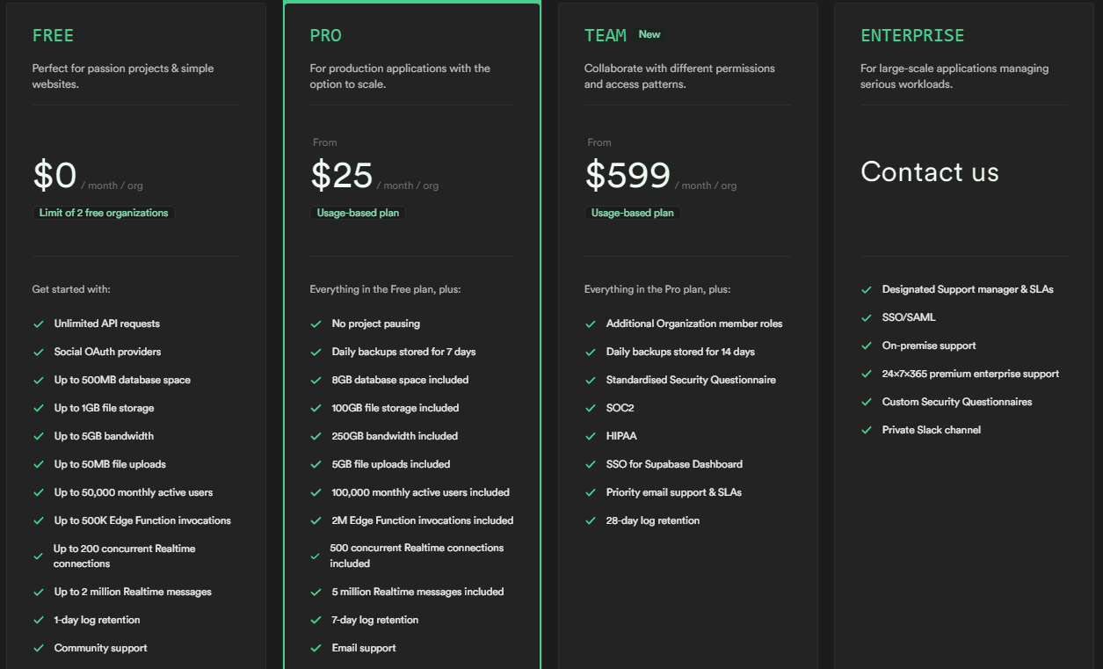

*Retool:* Just as the objective of this tool is different from the other two mentioned, its billing and payment methods are also different. ReTool bases its cost on the number of users (standard and end users) that use the application created in your environment. In other words, for each standard user (generally a team member, software developer, etc.), the platform charges an amount that is added to the value of each end user (user who uses the application on a daily basis), thus totaling the cost of using the tool. The ReTool pricing table can be viewed below. (https://retool.com/en/pricing).

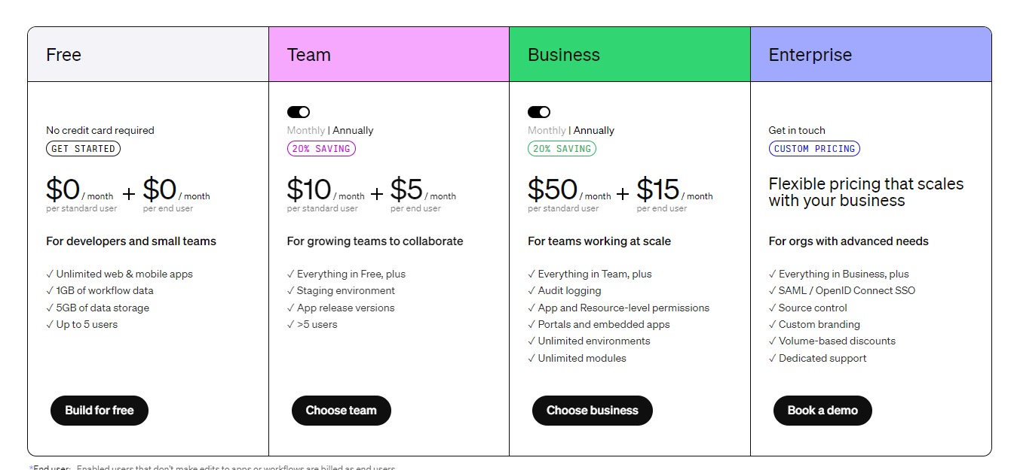

1. **Conclusion**

After all, which service is better? It all depends on the case. If you are looking for scalability, relational database structure and greater overall control over your application, it is safe to say that Supabase will efficiently meet your needs. If your concern is storing unstructured data and being directly integrated with Google's systems and services, Firebase will deliver what it promises. And finally, in parallel on the front-end part, you can use the No-Code ReTool tool to create your interfaces and connect them with one of the two tools discussed throughout this text. After all, as said, this one is much more connected to the look of your application, while Supabase and Firebase are more related to what happens behind the scenes.

1. **References**

SINGH, Navneet. **Why Supabase Is the Superior Choice Over Firebase**. 2023. Disponível em: <https://blog.bitsrc.io/why-supabase-is-the-superior-choice-over-firebase-a-comprehensive-comparison-f4e4814c7057>

GUZY, Dominik. **Why you should choose Supabase over Firebase**. 2022. Disponível em: <https://www.gorrion.io/blog/supabase-vs-firebase/>

WOKE, Goodness. **Firebase and Supabase: Key differences you need to know**. 2023. Disponível: <https://www.red-gate.com/simple-talk/development/other-development/firebase-and-supabase-key-differences/>

WILSON, Ant. **Firebase vs Supabase: Which one is better for your next project?**. 2022. Disponível em: <https://supabase.com/alternatives/supabase-vs-firebase>

KARCZEWSKI, Joey. **What is Retool and what is it good for?**. 2023. Disponível em: <https://blog.boldtech.dev/what-is-retool/>